C.Tharun
(192472309)
Exp No: 10
PIR SENSOR IN PROTEUS USING ARDUINO

AIM:
To write an Embedded C program for interfacing PIR Sensor using Arduino Uno and Proteus

SOFTWARE REQUIRED:
- Proteus 8 software.
- Arduino IDE software

CIRCUIT DIAGRAM:
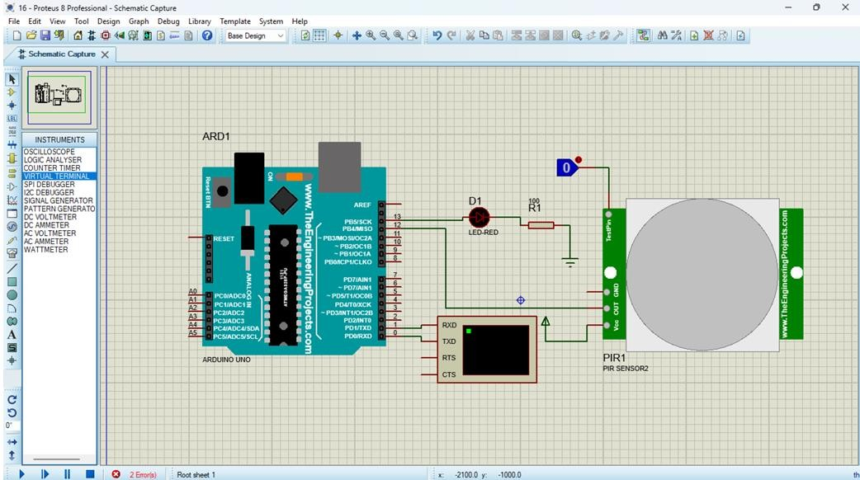
PROGRAM:
int Status = 13; // Digital pin D6 int sensor = 12; // Digital pin D7 void setup() { Serial.begin(9600); pinMode(sensor, INPUT); // declare sensor as input pinMode(Status, OUTPUT); // declare LED as output
}
void loop() {
long state = digitalRead(sensor); Serial.println(state); if(state == HIGH) { digitalWrite (Status, HIGH); Serial.println("Motion detected!"); delay(1000);
}
else {
digitalWrite (Status, LOW); Serial.println("Motion absent!"); delay(1000);
}
}

OUTPUT:
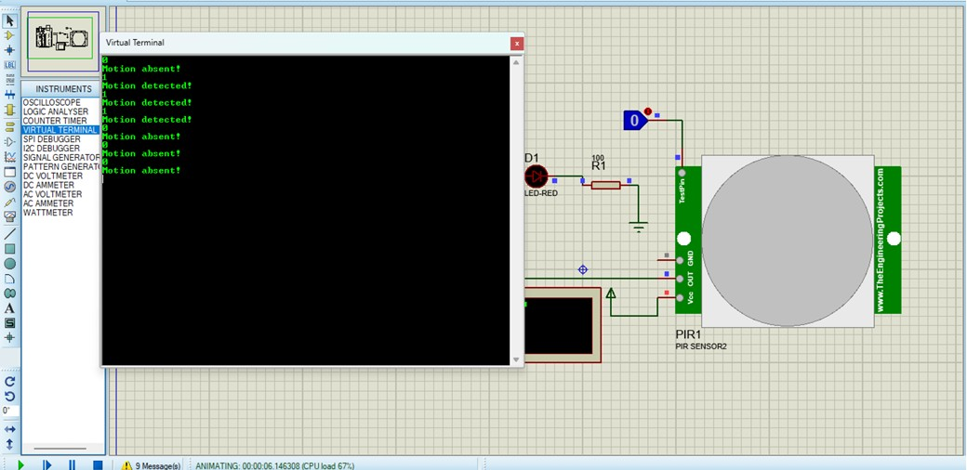
RESULT:
Thus the program has been successfully verified and executed.

